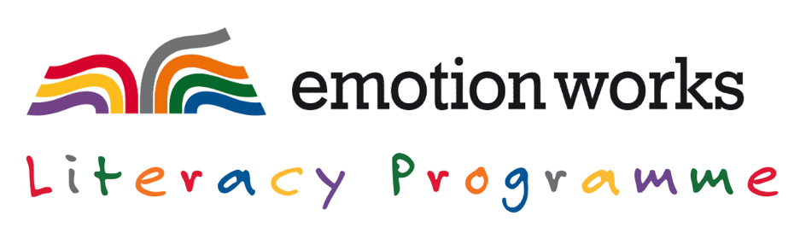
TEACHING SCHEDULE – nb. although outlined in ‘weeks’, you can work through the schedule at your own pace
BEFORE STARTING – Training & Preparation | - Staff new to Emotion Works - watch the ‘Getting Started’ Training Recording (2 hours)  - Staff already familiar with EW - watch the ‘Next Steps’ Training Recording (2 hours)  Then, teachers engage with (or re-familiarise themselves with) the ‘Getting Started’ Training and Teaching pages on the Emotion Works website
BLOCK 1: Introducing Emotion Works to Pupils
WEEK 1  Nb. feel free to take longer on this block if you or your group are new to Emotion Works  Live check-in about Block 1: Monday  30th August 4:30pm | INTRODUCING EMOTION WORKS to Pupils (or a reminder for pupils who have learned about EW before)  Early Level (Nursery) – What are Emotions & Feelings?  Using the ‘Emotion Characters Slideshow’ & Classroom Poster  Early Level (Lower Primary) – 5 Emotion Cogs 🟠 🔴 🟡 🟢 🔵  Using the ‘Introducing the 5-Cog Model Slideshow’ & Classroom Poster  First Level (Middle Primary) – 6 Emotion Cogs 🟠 🔴 🟡 🟢 🔵  Using the ‘Introducing the 6-Cog Model Slideshow’ & Classroom Poster  Second Level (Upper Primary/S1,2) – 7 Emotion Cogs 🟠 🔴 🟡 🟢 🔵 🟣  Using the ‘Introducing the 7-Cog Model Slideshow’ & Classroom Poster  TRACKING PROGRESS NOTE - Pupil responses during first conversations about the Cogs during this Introductory Block can be recorded and kept on file to track depth of emotional understanding over time. You could also use our ‘Timed Assessment’ tool to check starter levels of understanding more formally.
BLOCK 2: ‘Word Works’ – identifying and expanding the vocabulary & language related to each of the cogs
WEEKS 2-3  Nb. feel free to take longer on this block if you or your group are new to Emotion Works  Live check-in about Block 2: Monday 13th September 4:30pm |   As you move on to take a closer look at each cog concept with pupils, we help you focus in on developing the vocabulary and language associated with each cog through our ‘Word Works’ activities and resources.  Early Level (Nursery) – What are Feelings & Emotions?  Words and Pictures that help us talk about our Feelings and Emotions (linked to the first 5 cogs)  Using the Feelings & Emotions slideshow, Classroom Poster, and foundation symbol resources  Early Level (Lower Primary) – 5 Emotion Cogs 🟠 🔴 🟡 🟢 🔵  The words and language we use to help us talk about the Emotion Works Cogs  Using the 5-Cog Model Slideshow, Classroom Poster, 5x Cog slideshows and resources  First Level (Middle Primary) – 6 Emotion Cogs 🟠 🔴 🟡 🟢 🔵  The words and language we use to help us talk about the Emotion Works Cogs  Using the 6-Cog Model Slideshow, Classroom Poster, 6x Cog slideshows and resources  Second Level (Upper Primary/S1,2) – 7 Emotion Cogs 🟠 🔴 🟡 🟢 🔵 🟣  The words and language we use to help us talk about the Emotion Works Cogs  Using the 7-Cog Model Slideshow, Classroom Poster, 7x Cog slideshows and resources  TRACKING PROGRESS NOTE - Pupil responses during first Word Works activities can be recorded and kept on file to track word knowledge improvements over time. You could also use our ‘Quick Assessment’ tool to check Emotion Word and Regulation Strategy knowledge more formally.

BLOCK 3: Exploring different types and categories of emotions using Emotion Works cogs and concepts
WEEKS 4-9  Nb. feel free to take longer on this block if you or your group are new to Emotion Works  Live check-ins about Block 3: Mon 27th Sept, 11th & 25th Oct 4:30pm | In Block 3 we help you to develop and deepen your pupils emotional understanding by focusing on one emotion at a time. Using a piece of literature featuring the weekly emotion as a stimulus, we demonstrate how to share and explore emotional content with pupils using the cog framework.  We provide suggestions for literacy starters for each emotion category (including books, excerpts, poems, movie shorts, film clips, song lyrics etc.) and demonstrate how Emotion Works learning can take place across the different levels through a variety of talking, listening, reading, and writing activities.  The examples we share can then be integrated into your own practice, or you can use our suggestions as inspiration to apply the teaching ideas to your own choice of text or literacy stimulus.
WEEK 4 |   Nice Feelings, Positive Emotions: Happy, Joyful & Excited category  Using an emotion character slide, symbol & cog resources, and selected texts
WEEK 5 |   Not nice feelings, Negative Emotions: Sad, Upset & Disappointed category  Using an emotion character slide, symbol & cog resources, and selected texts
WEEK 6 |   Nice Feelings, Positive Emotions: Calm, Relaxed & Peaceful category  Using an emotion character slide, symbol & cog resources, and selected texts
WEEK 7 |   Not nice feelings, Negative Emotions: Frightened, Scared & Worried category  Using an emotion character slide, symbol & cog resources, and selected texts
WEEK 8 |   Not nice feelings, Negative Emotions: Angry, Annoyed & Frustrated category  Using an emotion character slide, symbol & cog resources, and selected texts
WEEK 9 | Other feelings and emotions – suggestions will be provided, or choose your own
BLOCK 4: Applying Emotion Works learning to a Book or Film Study or other Literacy Stimulus
WEEKS 10-12  Nb. feel free to take longer on this block if you or your group are new to Emotion Works  Live check-ins about Block 4: Mon 8th & 22nd Nov 4:30pm | Book Study / Film Study / TV Series / Another literacy theme or topic  Block 4 of the Literacy Programme involves delivering a plan of Emotion Works lessons based around a class novel, author/book study, TV series/film study or another literacy theme or topic.  You can opt to make use of one of the Book or Film study plans we provide, or you can identify your own stimulus linked to a class topic or school context and develop your own plan.  If you would like to incorporate your literacy and Emotion Works planning into a broader learning theme, we also provide some examples showing how Emotion Works and Literacy can be incorporated IDL planning.
PLENARY
After completion  Live Plenary check-in & showcase discussion: Mon 6th Dec 4:30pm | Plan a Showcase of Work to celebrate your Emotion Works and Literacy learning  Showcase examples from across the Emotion Works community and new ideas for Literacy Programme celebrations will help you plan an end of programme event or presentation of work (such as a parent afternoon with class visits, a film compilation with contributions from different classes, a special assembly or other celebratory event for your school community etc.)

 www.emotionworks.org.uk/members-dashboard/literacy-programme

TRAINING CONTENT – INCLUDED IN LITERACY PROGRAMME & FULL SCHOOL SUBSCRIPTIONS
GETTING STARTED INSERVICE TRAINING  - Online  - 2 hours  Join us live on the morning of 11th or 16th AUGUST or register for the link to watch the recording in your own time. | 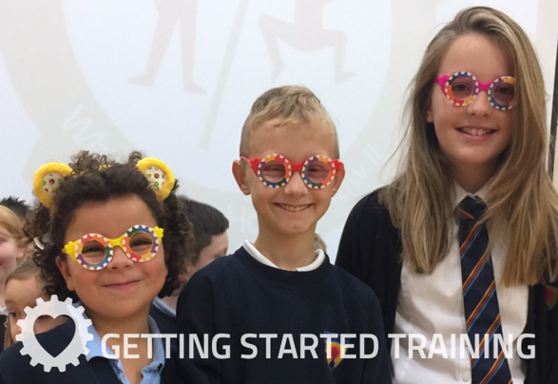  FOR SCHOOLS & TEACHERS NEW TO EMOTION WORKS  This live online training will be delivered via the Zoom platform using a webinar style approach. It will be geared towards whole staff teams who are just starting out using the Emotion Works programme. It will include…  - An introduction to the Cog Curriculum  - Progression Guidelines  - Scottish Curriculum & Policy links  - Website tour of the ‘Getting Started’ training & teaching material  - Literacy Programme Teaching Ideas  The training will be delivered by Claire Murray (Programme Creator) with Vicki Renton, Emotion Works Primary School Advisor along with a guest Primary Practitioner sharing their whole school approach to getting started with EW in their school.  Please note – this Training and the Literacy Programme in general will also be useful to Early Years/Nursery staff and S1/2 staff interested in using Emotion Works within a BGE programme.
CONSOLIDATION & NEXT STEPS INSERVICE TRAINING  - Online  - 2 hours  Join us live on the morning of 13th or 17th AUGUST or register for the link to watch the recording in your own time. | 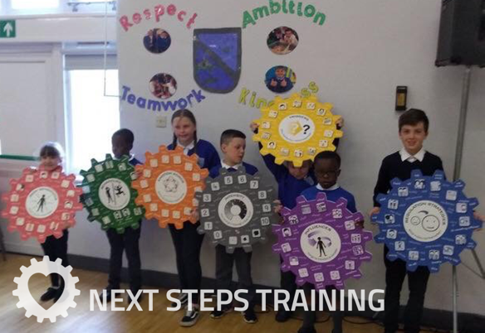  FOR SCHOOLS & TEACHERS WHO ARE ALREADY FAMILIAR WITH EMOTION WORKS  This live online training will be delivered via the Zoom platform using a webinar style approach. It will be geared towards whole staff teams who have been using Emotion Works for a while and pupils have already been introduced to the programme. It will include…  - A reminder of the Cog Curriculum and Progression Guidelines  - A look at how to use Emotion Works alongside a variety of Curriculum Areas  - An in-depth look at the Literacy Programme roll-out and Teaching Ideas  - Whole School planning  The training will be delivered by Claire Murray (Programme Creator) with Vicki Renton, Emotion Works Primary School Advisor along with a guest Primary Practitioner sharing how they have embedded Emotion Works across the school beyond their first roll-out.
TEACHERS WHO ARE NEW TO EW  Self-directed / collegiate training amounting to around 4 hours CPD | Following the ‘Getting Started’ Inservice training session, teachers who are not yet experienced in using EW – the ‘GETTING STARTED’ training pages provide a more in-depth look at…  - The Component Model Curriculum  - Component Model Progression  - ‘Closer Look’ Training for each Individual Cog  The corresponding teaching pages will then support with planning first learning activities at the right level for different learners.
FORTNIGHTLY CHECK-INS  Mondays at 4:30-5pm | To support you further as you work through the Literacy Programme, we’ll be hosting live, online fortnightly check-ins where we’ll share practice examples from across the #EWcommunity and answer any questions about roll-out you might have.  Dates:

Purchase online www.emotionworks.org.uk/shop/all-products

