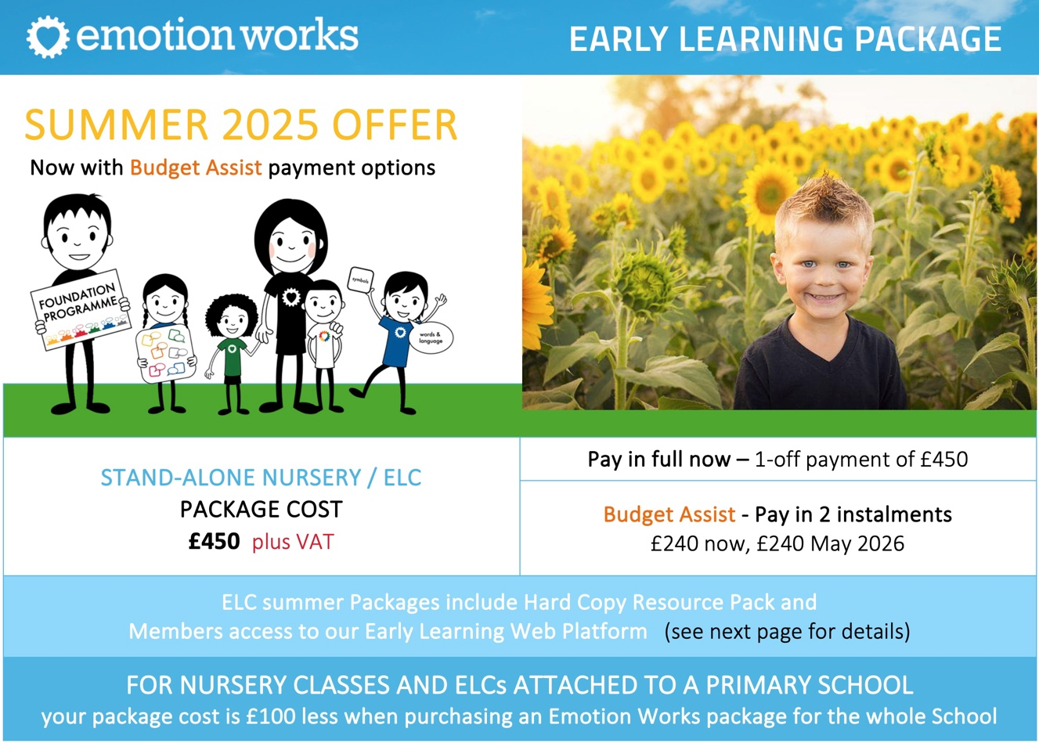

PURCHASE PACKAGE as a STAND-ALONE ELC or NURSERY. To secure this Summer 2025 Special Offer please provide the information required below and return to office@emotionworks.org.uk

ELC / Nursery name
Local Authority / Location
Senior Manager Name  Email address | Name  Email address
Office email address  (such as enquiries@ or nurseryname@ etc.) | Email address
Address for invoice & resource delivery | Address
Your PO Number if raised, or Reference if required
Payment Choice – Please indicate how you would like to pay for your package (all quoted prices exclude VAT) | 1-off payment of £450* now | OR | 2 instalments
 |  |  | £240* now |  | £240* May 2025
Lead Practitioner Name  Email address (for web membership) | Name  Email address
Symbol Choice – Please indicate the symbols you’d like to feature on your Hard Copy Symbol Resources (preview on next page) | Emotion Works  Character symbols | OR | Boardmaker (PCS)  symbols
Optional Extras (preview on next page)  Please let us know if you’d like to include any extra resources with your package at this stage and we can add this into your initial purchase cost & instalment calculation if required.  Please note that extra resources purchased in future will need to be paid in full. |  |  |  | How many?
 | Model in Mind Poster & Discussion Tool £15
 | Training & Planning Document Bundle £5
 | Feelings & Emotions Poster & Prompt Set £15
 | Symbol Book £15
 | Full Symbol Card Set £30
 | Extra notes or requests
*If you opt to add extra resources, we will recalculate your total package and instalment cost and check back with you with your new quote before raising your invoice & processing your order.
